
NAME: ______________________________

KELMSCOTT SENIOR HIGH SCHOOL
ATAR Human Biological Science Unit 3

HOMEOSTASIS

QUESTION/ANSWER BOOKLET

STRUCTURE OF THIS PAPER:

Section | Number of questions available | Marks allocated | Your Marks
Multiple Choice | 10 | 10
Short Answer | 4 | 40
Extended Answer | 1 | 10

MARK / 60

MARK: _______________________%

KELMSCOTT SENIOR HIGH SCHOOL
ATAR Human Biological Science Unit 3

HOMEOSTASIS

Place a X through the best answer.

X
1 |  | (a) | (b) | ( c) | (d)
2 |  | (a) | (b) | ( c) | (d)
3 |  | (a) | (b) | ( c) | (d)
4 |  | (a) | (b) | ( c) | (d)
5 |  | (a) | (b) | ( c) | (d)
6 |  | (a) | (b) | ( c) | (d)
7 |  | (a) | (b) | ( c) | (d)
8 |  | (a) | (b) | ( c) | (d)
9 |  | (a) | (b) | ( c) | (d)
10 |  | (a) | (b) | ( c) | (d)
X
X
X
X
X
X
X
X
X

Section B Short Answer Questions

11. This question refers to the table below giving the concentrations of glucose in the blood taken from an individual during a 5 hour period. At the start of recording, and for a further 90 minutes, blood glucose level was within normal limits. Following a meal the glucose levels increased, then decreased back to normal levels within 90 minutes. This individual then went for a one hour run. During this one hour run, blood levels decreased and remained low for a further 60 minutes.

Time (Minutes) | Blood glucose concentration (mg/100mL)
0 | 100
30 | 95
60 | 100 (glucose concentration normal)
90 | 105 (following meal)
120 | 150
150 | 120
180 | 100 (started a 1 hour run)
210 | 95
240 | 75 (end of 1 hour run)
270 | 70
300 | 75

a. Using the above data plot the changes in the blood glucose levels over time.
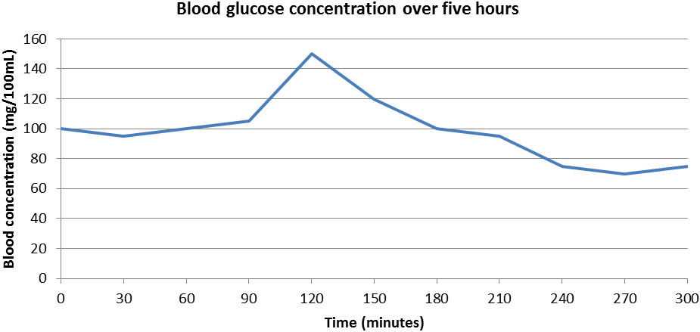
(6 marks)

Title (1), Labels and units (2), correct scale (1), Accurate plotting (1), Line (1)

b. If respiration is constantly using up glucose why did the glucose concentration in the blood remain relatively constant during the first 90 minutes? (1 mark)

Glucose being used was replaced via the conversion of glycogen to glucose (glucogenesis)

c. State two reasons why glucose concentration the blood rose after the meal?
(2 marks)
  - Because food eaten was being broken down into glucose (1)
  - Glucose was absorbed into the blood stream (via alimentary canal) (1)

d. Why did glucose concentration in the blood decrease during the one hour run?
(1 mark)

Respiration rate increases. This increase in respiration uses more of the bodies blood glucose.

e. Predict what the glucose concentration would be 2 hours after the run if no more food was eaten. (1 mark)

100mg/100mL (+or- 5)

12. A biologist is studying animal life in Antarctica, where the average daily temperature is -50 ̊C. His work requires him to be in the open air making observations over long periods of time.

  - Describe ONE behavioural modification he would need to make, apart from wearing warmer clothing, when outside observing animals. (1 mark)

- Light a fire
- Huddle out of the wind
Any reasonable

- Use heat bags in his clothes.
- Eye protection
- Breathing equipment

  - Physiological mechanisms are also essential for the scientist to maintain his core temperature in these freezing conditions.

Name two (2) mechanisms that his nervous system would control and explain how they would maintain his core temperature (2 marks)
Cerebrum – voluntary movement (e.g. rub hands) (1) – ↑ respiration → ↑ heat prod (1) OR
Hypothalamus - sympathetic stimulation of muscles → shivering (1) →↑ heat prod (1)
Or
Hypothalamus - ↑ TRH → ↑ TSH → ↑ Thyroxine (1) → ↑ MR → ↑ Heat prod (1)

  - What is the modulator for body temperature? (1 marks)

Hypothalamus

  - Two other biologists are studying other animal species in completely different conditions to that in Antarctica. One is in a hot desert and the other is in a tropical rainforest. Both climates have a similar average daily temperature of 34 ̊ C. However, the biologist in the desert feels relatively comfortable whereas the one in the tropical rainforest finds it very uncomfortable. Explain why? (1 marks)

- There is more humidity in the rainforest than the desert. (1 mark)
- When there is a lot of humidity your sweat won’t evaporate. Sweat evaporates cooling you down in the desert but not the rainforest. (1 mark)

  - After a period of time without nourishment, the blood volume of the biologist in the desert would change more than that of the biologist in the tropical rainforest.

- Describe the change that would occur to the biologist in the desert. (1 marks)

- The desert biologists blood volume would decrease (1 mark)

ii. Explain your answer to part (d) (i) (2 marks)

- This is because he is sweating more (1) and his sweat is evaporating away (1)

- Explain how this change could affect his actual blood pressure. (2 marks)

- Lower blood volume = smaller recoil in his arteries (1mark)
- Smaller recoil in arteries = reduced blood pressure. (1 mark)

13. Experiments were carried out in which a naked person was asked to sit in a room while the temperature around them was gradually lowered and raised. Tests were conducted in environmental temperatures between 0oC and 40oC. The graph below shows a generalised graph of what happened, with extrapolations beyond the actual temperatures tested.
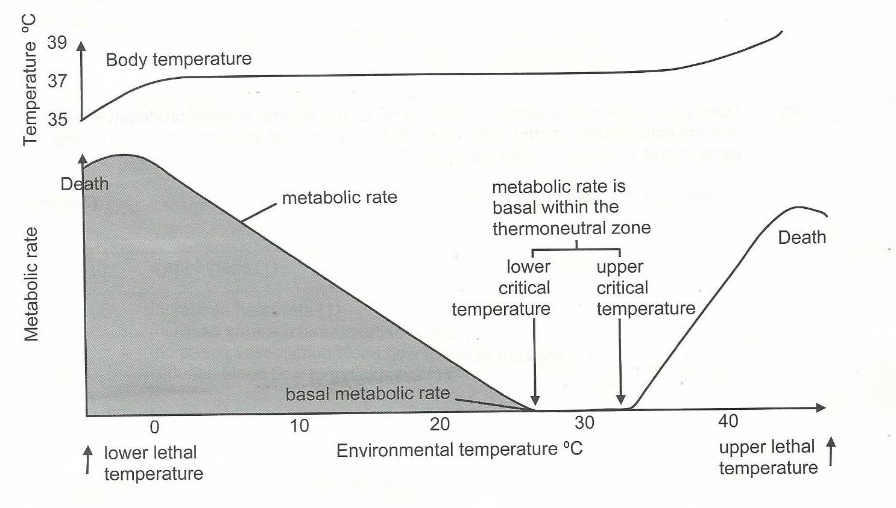

- What changes in behaviour could influence metabolic rate below the lower critical temperature? (2 marks)
Putting on clothes (1)
Curling up / ↓ SA:Vol (1)
↑ movement/activity (1),
hot drink/food (1)

b) Why would the production of thyroxine change with a change in environmental temperature from 10ºC t0 25ºC? (2 marks)
Thyroxine production would be reduced with an increase in temperature (1)
Thyroxine increases metabolic rate (1)
Metabolic rate/heat production decreases with an increase in temperature (1)

c) State two methods of heat loss from the body within the thermoneutral zone.
(2 marks)
Conduction, Convection, Radiation, Evaporation any 2 for 2

d) How would environmental conditions other than temperature affect heat loss at temperatures above the upper critical temperature? (2 marks)
level of humidity affecting evaporation (1)
air movements – affecting convection and evaporation (1)
radiating/reflective surfaces (1)

e) During the experiments carried out above 35oC, the volume of urine produced was less and the concentration of the urine was greater than that of the urine produced during the experiments conducted in the themoneutral zone.

Explain why this would happen. (3 marks)
Water/sweating used in evaporative cooling (1)
Reduced water available for urine production (1)
↑ osmotic pressure (1)
Same amount of wastes in a smaller water volume – more concentrated urine (1)
↑ ADH → ↑ H₂O reabsorption → ↓ urine volume (1)

14. An investigation was carried out into the effects of exercise on the heart rate and breathing rate of a student. Her hear rate, breathing rate and blood pH were first measdured at rest. Data were collected after she had cycled for 2 minutes at 5 km/hr on an exercise bicycle. After resting for 5 minutes, the procedure was repeated at cycling speeds of 10, 15,20 and 25 km/hr. The results are shown in the table and graph below.

Cycling Speed (km/hr) | Heart rate (beats/min) | Breathing rate (breaths/min)
0 | 64 | 12
5 | 70 | 13
10 | 80 | 14
15 | 100 | 17
20 | 140 | 20
25 | 180 | 27

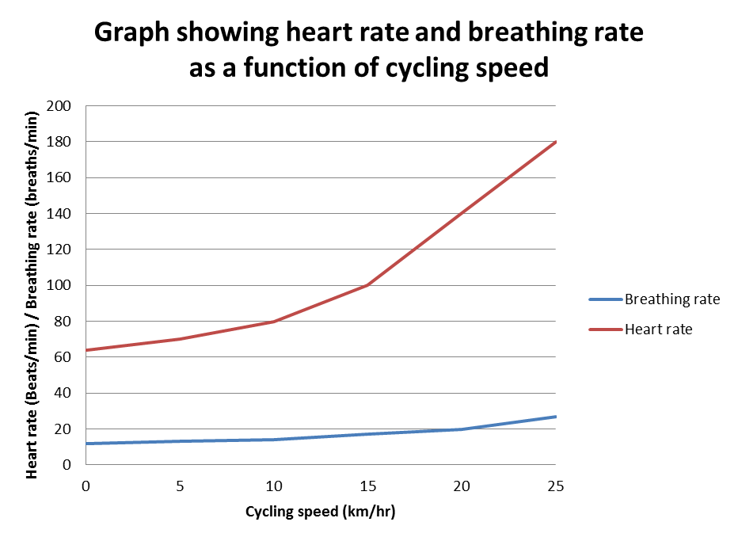

- Describe the relationship between cycling speed and heart rate. (1 mark)

As cycling speed increases, heart rate increases (1) / direct relationship (1) / +ve correlation (1)

b) Explain the changes in breathing rate as the cycling rate increased. (3 marks)
Breathing rate increases due to build up of carbon dioxide/H+/low pH (1)

From increased respiration rate required to supply energy for cycling (1)
detected by the respiratory centre/chemoresceptors in the medulla (1)
(sympathetic) stimulation of intecostal/diaphragm muscles (1) which increases the rate of breathing

c) During the investigation, the student was given a 5 minute rest between each 2-minute cycling session. Suggest why this was done. (1 mark)

Improve the reliability/validity of results (1)
Allow time for heart rate /breathing rate to return to normal / recovery time before repeating the cycling activity (1)

d) The student in this investigation had blood samples taken before any cycling activity and at the end of the investigation. The pH was measured for both samples and it was found that the pH had dropped from 7.4 to 7.2 during the investigation

Explain why this change would have occurred. (3 marks)

pH is changed with the level of carbon dioxide (1)
lactic acid produced (1)
increased respiration increases carbon dioxide (1)
carbon dioxide in blood releases H+/produces carbonic acid causes a decrease in pH (1)

Section C – Extended Answer - 10 marks
15. Susarnah was part of a research group investigating the control of blood glucose levels in different people. The graph below shows the changes in her blood glucose levels over a period of 24 hours.
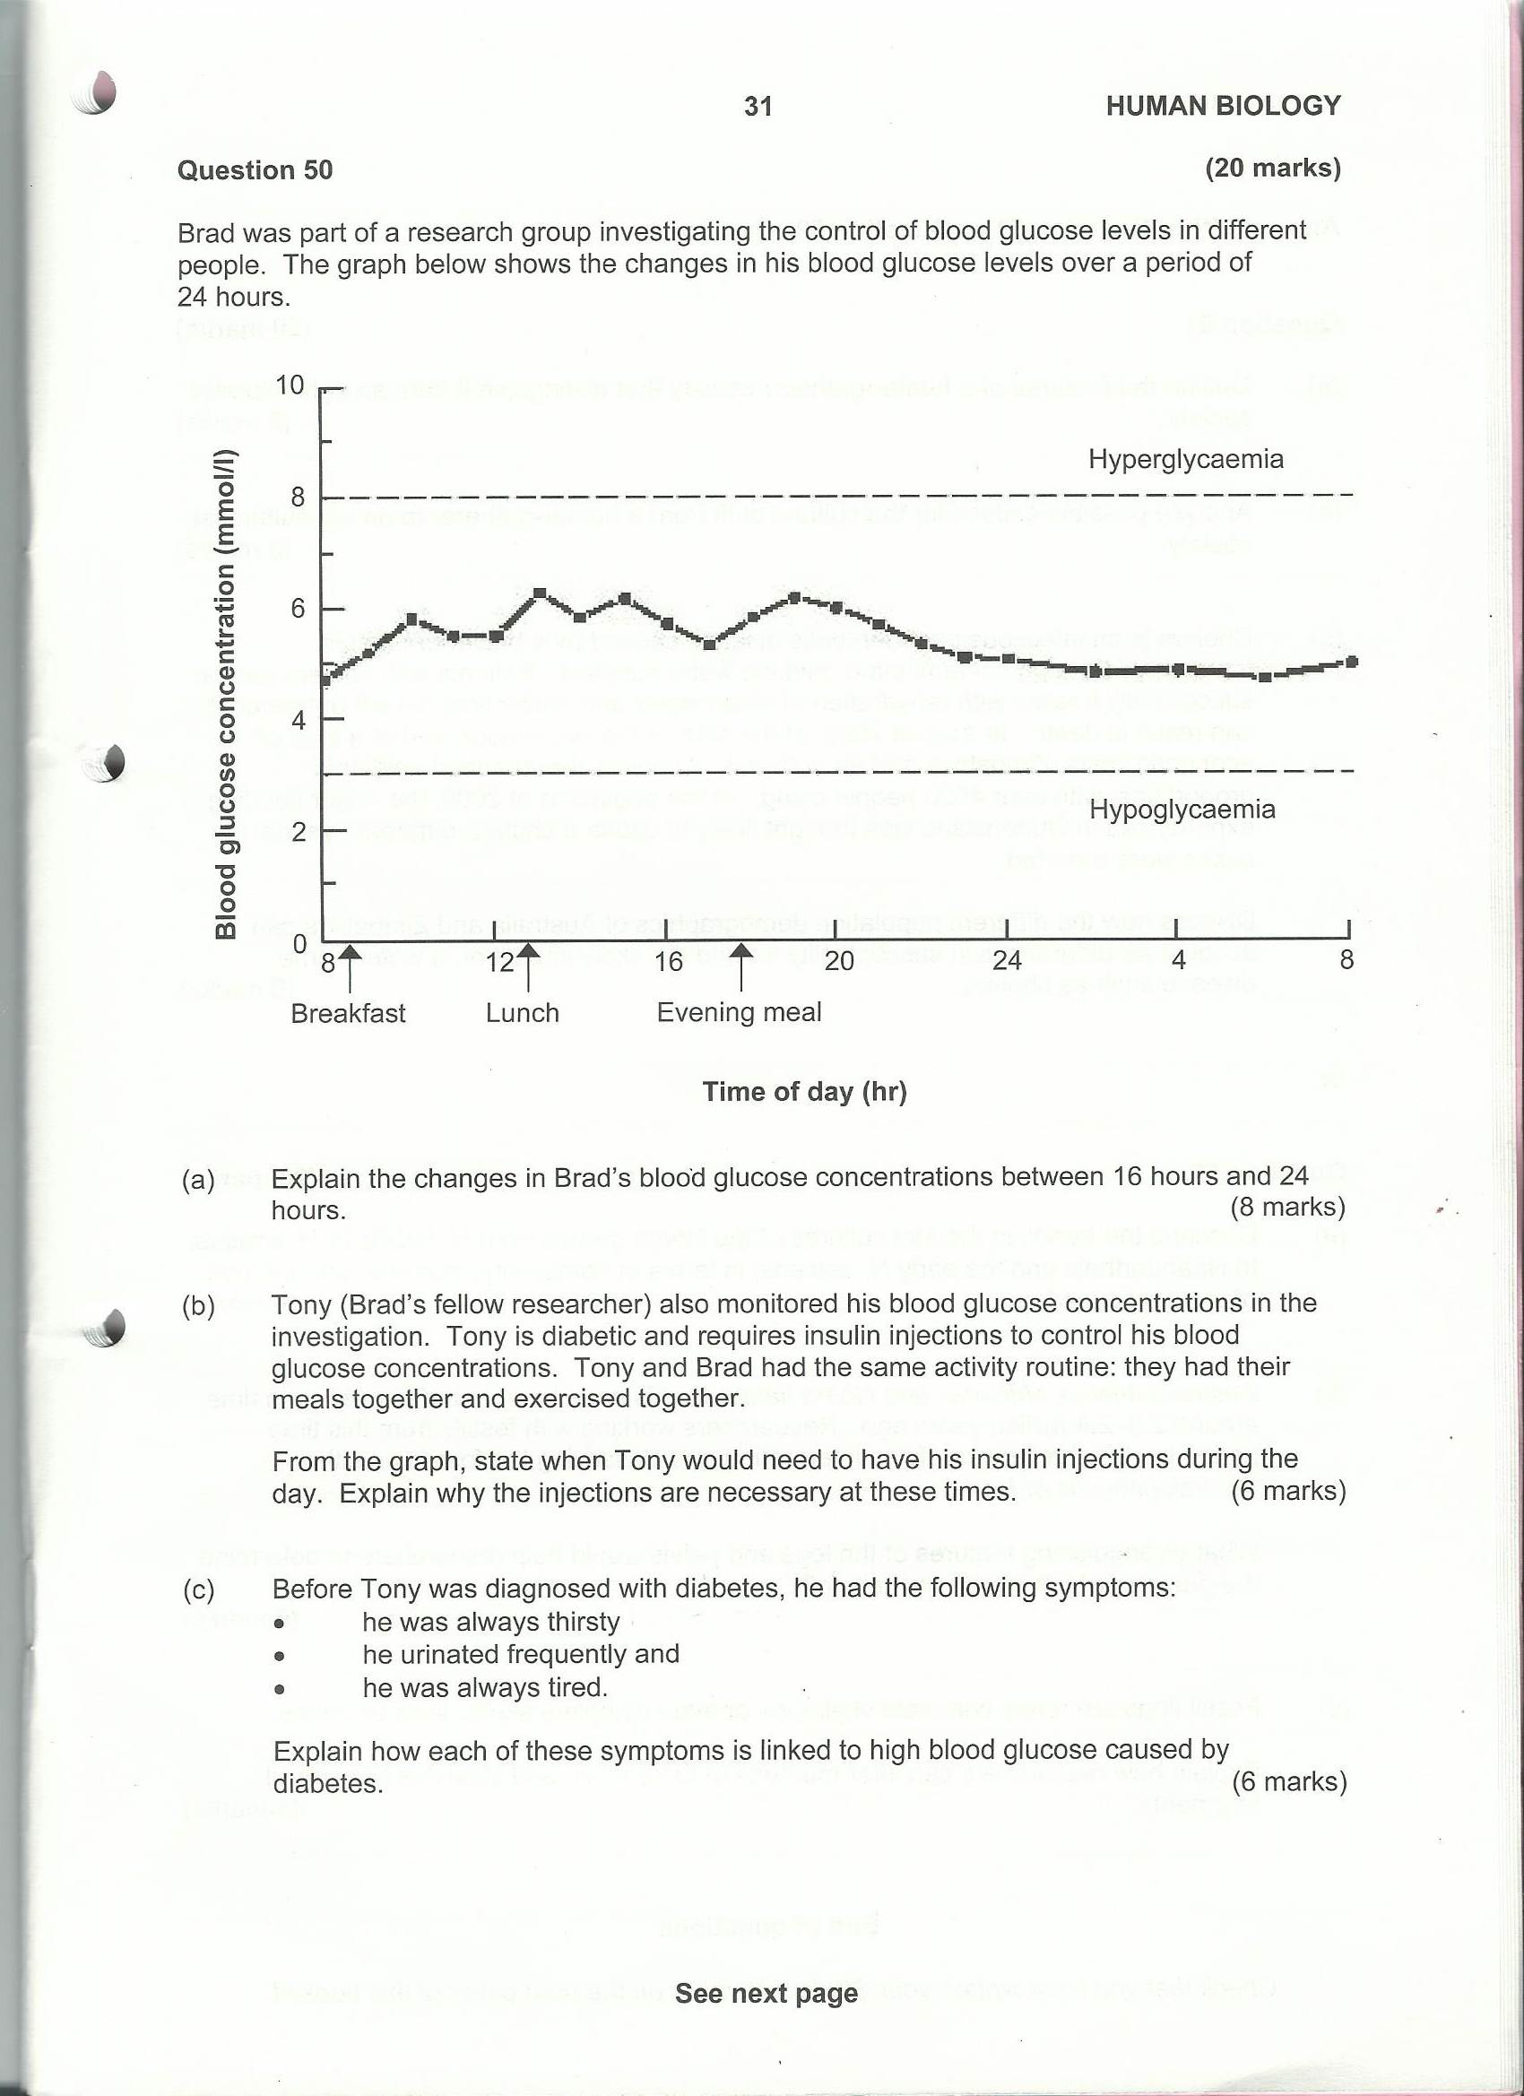

(a) Kasa (Susarnah’s fellow researcher) also monitored her blood glucose concentrations in the investigation. Kasa is diabetic and requires insulin injections to control her blood glucose concentrations. Kasa and Susarnah had the same activity routine: they had their meals together and exercised together.
From the graph, state when Kasa would need to have her insulin injections during the day. Explain why the injections are necessary at these times. (6 marks)

b) Before Kasa was diagnosed with diabetes, she had the following symptoms:
- she was always thirsty
- she urinated frequently
- she was always tired
Select two of these symptoms and explain how each is linked to high blood glucose caused by diabetes. (4 marks)

(a) Kasa (Susarnah’s fellow researcher) also monitored her blood glucose concentrations in the investigation. Kasa is diabetic and requires insulin injections to control her blood glucose concentrations. Kasa and Susarnah had the same activity routine: they had their meals together and exercised together.
From the graph, state when Kasa would need to have her insulin injections during the day. Explain why the injections are necessary at these times. (6 marks)

Kasa would need insulin injections at
- Just before breakfast / 8:30 (+/- 30 minutes) (1)
Or at the meal time, e.g. at breakfast, at lunch,…
- Just before lunch / 12:30 (+/- 30 minutes) (1)
- Just before evening meal / 17:00 (+/- 30 minutes) (1)
- Just before meals (1)
Any 2 for 2

- Insulin promotes the uptake of glucose by cells (1)
- Meals provide a source of glucose from food (1)
- Bgl will increase after each meal (1) due to absorption from the digestive system (1)
- Need to remove excess bgl to maintain it within tolerance limits (1)

Any 4 for 4

b) Before Kasa was diagnosed with diabetes, she had the following symptoms:
- she was always thirsty
- she urinated frequently
- she was always tired
Select two of these symptoms and explain how each is linked to high blood glucose caused by diabetes. (4 marks)

Thirsty
- High bgl causes high osmotic pressure (1)
- drawing water out of cells into circulation (1)
- Which triggers the thirst reflex; thirst occurs mainly due to dehydration (1)
Max 2 marks

Urination
- High blood volume caused by excess water from cells causes kidney to remove large amounts of water from the body as urine (1)
- High frequency of urination occurs because excess glucose excretion by kidney affects reabsorption efficiency of kidney (1)
- Increased blood pressure increases urine production (1)
Max 2 marks

Tired
- Low/no glucose is being absorbed by cells causing low metabolic rate (1)
- and lack of energy for activity and tired feeling (1)
2 marks

Acknowledgements
Q 9. Figure adapted from SCSA Tertiary Entrance Examination, 2009, Question Answer Booklet, pg 7.
Q 13. Figure adapted from SCSA Tertiary Entrance Examination, 2009, Question Answer Booklet, pg 21.
Q 15. Figure adapted from SCSA Tertiary Entrance Examination, 2009, Question Answer Booklet, pg 31.

